LOG4J

1)What is the log4j?

Log4j is a Framework,Framework means semibuilt application.

2)why is use log4j?

3)where we use log4j?

4)what is the importance of log4j?

The importance of log4j whenever we write a simple java application we want to know are we getting the exact output or not, we want test our application with the connection establishment is perfectly happening or not.

Normally check for this scenario we use System.out.println(“…..”);

This is used to find out a errors.

By writing this System.out.println,this is not effective Application.

Just think you have 500 lines of code which code is if you want to test it,so how many Sysources you have to write?

Many system.out.println we have to write.after you writing a System.out.println your application is working good and output is fine,

1)but whenever you give your project to your client System.out.println should be there are shouldn’t be there?

2)After 1year that respective person comes to you and he asks to do add some more analsment and some ore functionalities.

In previous code only you have written 500 lines of code and approximately 100 lines of S.O.P and removed the S.O.P in code and you gave to the client, But this time again you have to write the 100 lines of code to add more features and again you have to write 150 lines of S.O.P’s.

*Beacaus of this process your application effectiveness is missing.

In this we have to remove s.o.p and adding s.o.p are time taking factors.

*So to avoid such type of scenario

1)we have to save the time to go for this concept

2) In previous code only you have written 500 lines of code and approximately 100 lines of S.O.P and removed the S.O.P in code and you gave to the client,if want to add new features again you have to add S.O.P.

3)To overcome this problem we are using log4j.

**When I write a log4j if I want it if I don’t want it I can control by using a Control flags.

That is

1)OFF

2)ALL

Here in this previous java code 500 lines of java code if I want to remove the 100lines of S.O.P code manually I have to go and remove it,for this removing 100lines we have take much care,in this same scenario By using log4j if you use this type of the constant you can control means you can desirable all this 100 loger statements.

By using control flags we can control the loger statements in “log4j”.

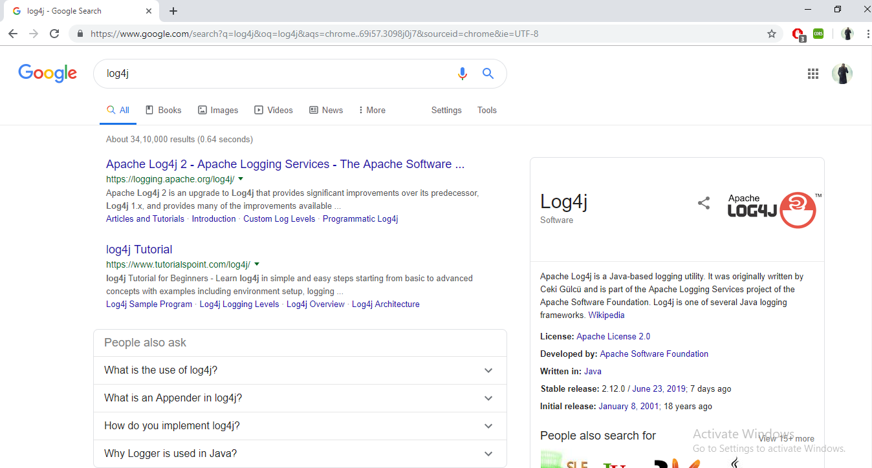

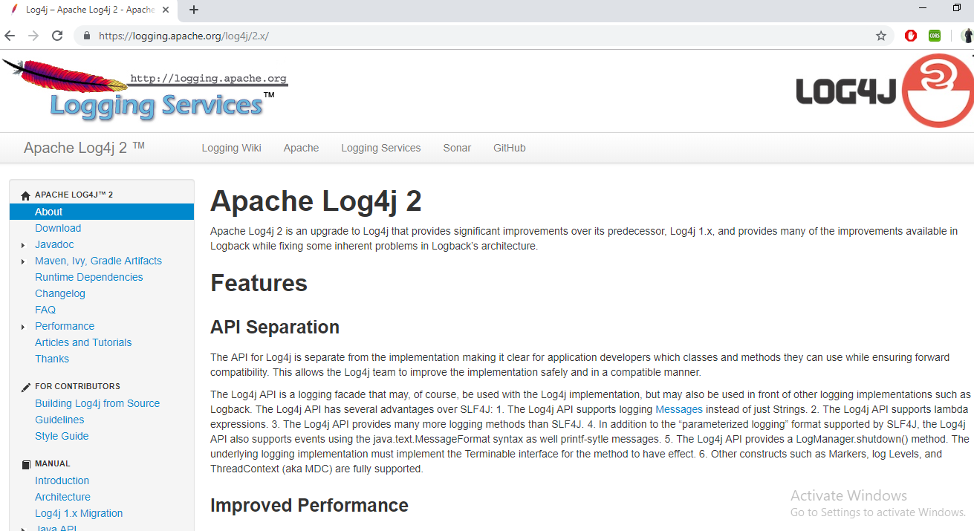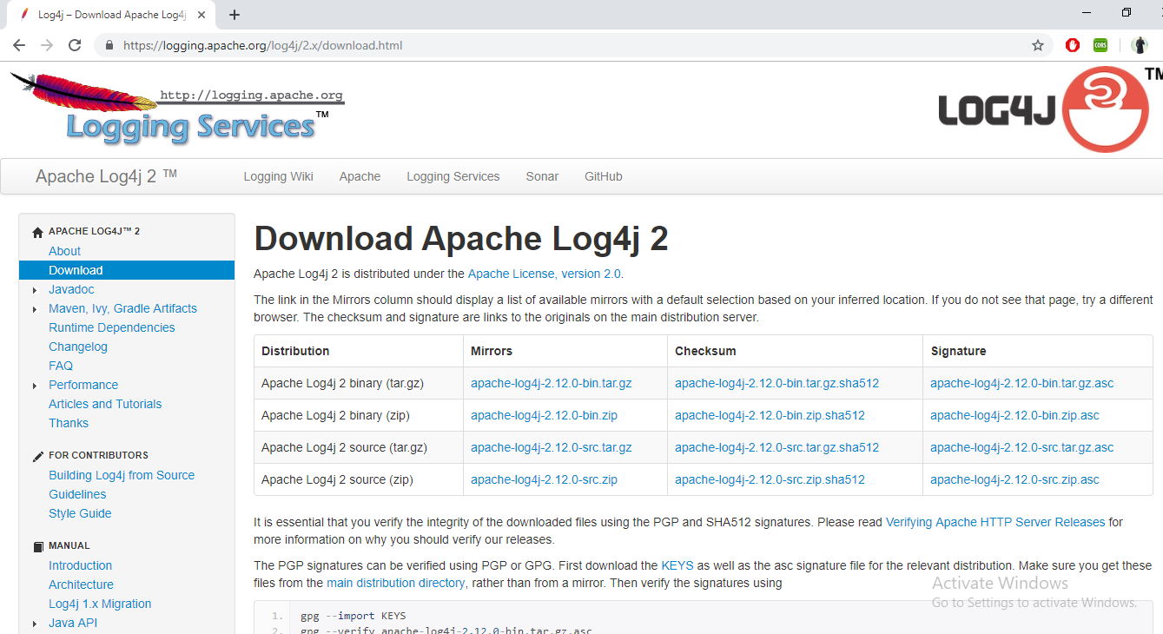

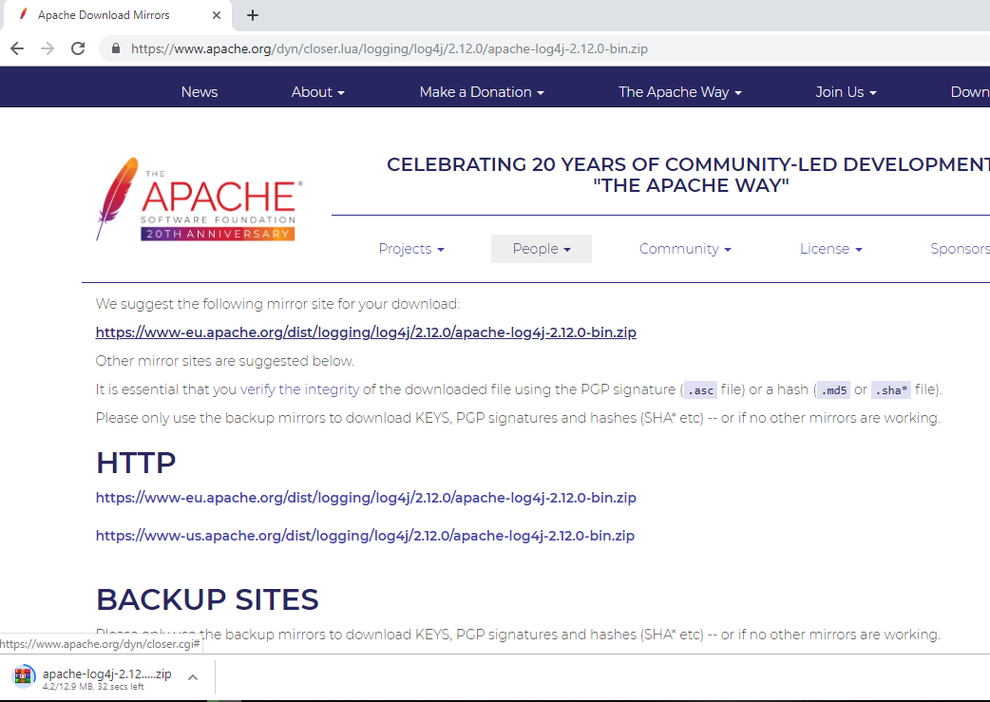

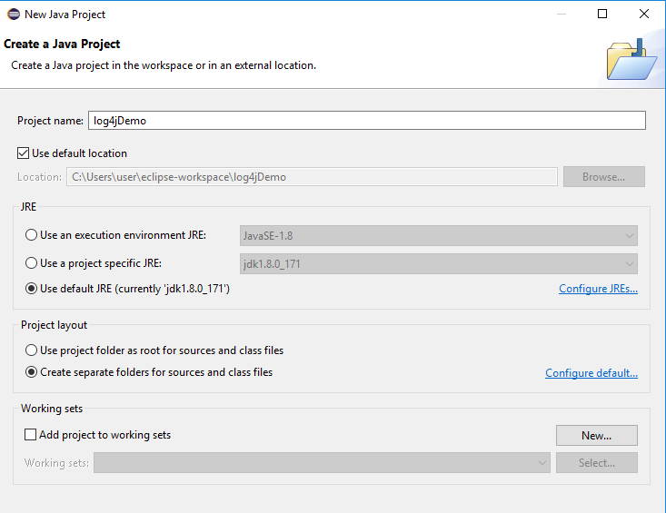

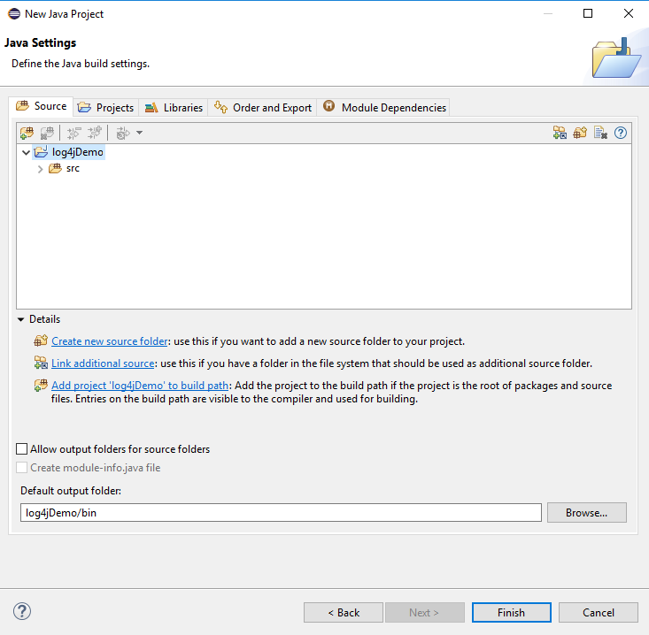

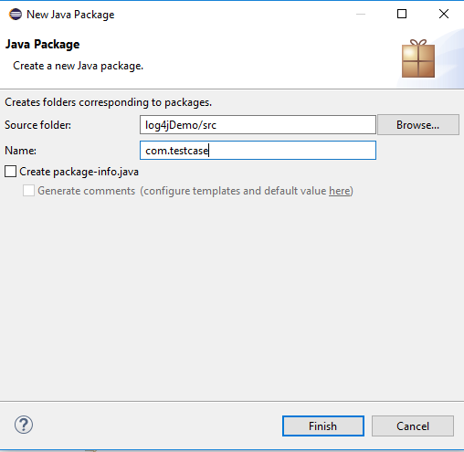

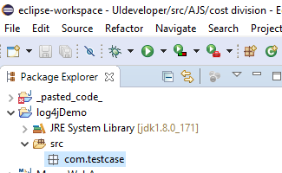

We need to add the log4j HR for that right click on log4j and go to properties,and click on javabuild path click on libraries in that there is add external JAR,s will be there just click it on

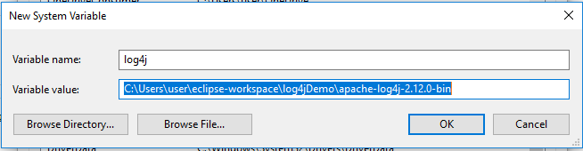

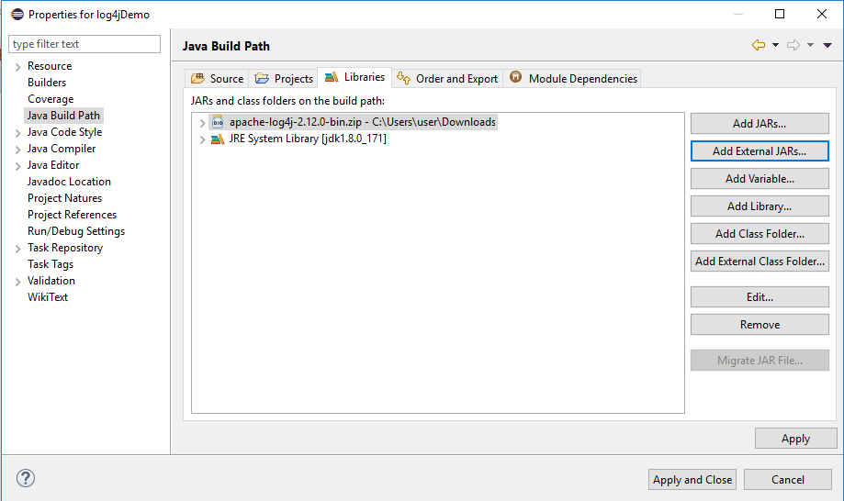

Log4jDemo will be open in Eclipse.

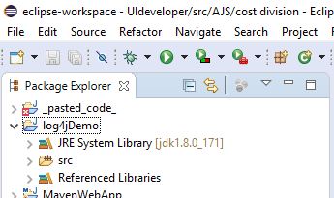

How to integrate log4j with maven project in eclipse:--

We have to add the Log4j dependencies in maven pom.xml.

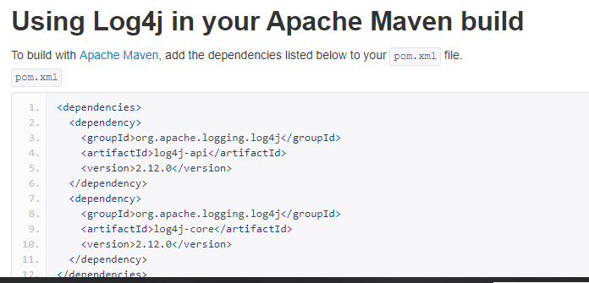

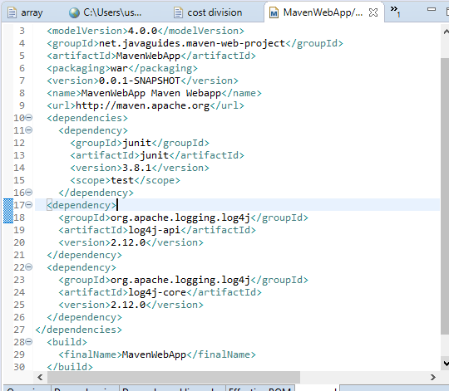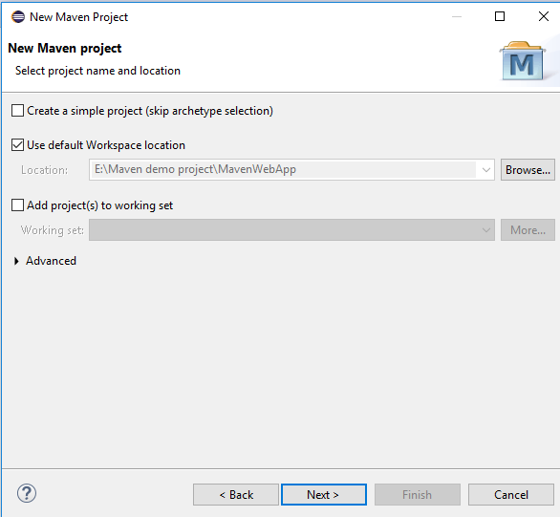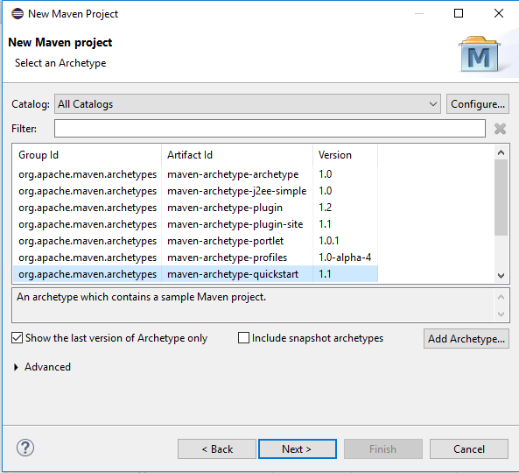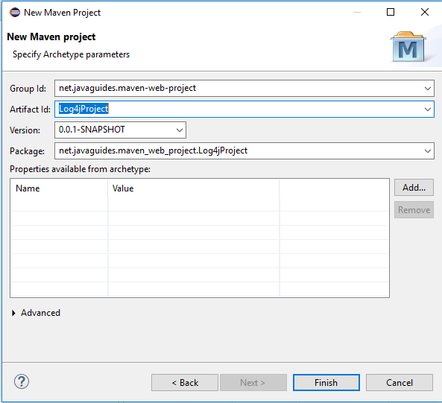

Go to main and create new folder

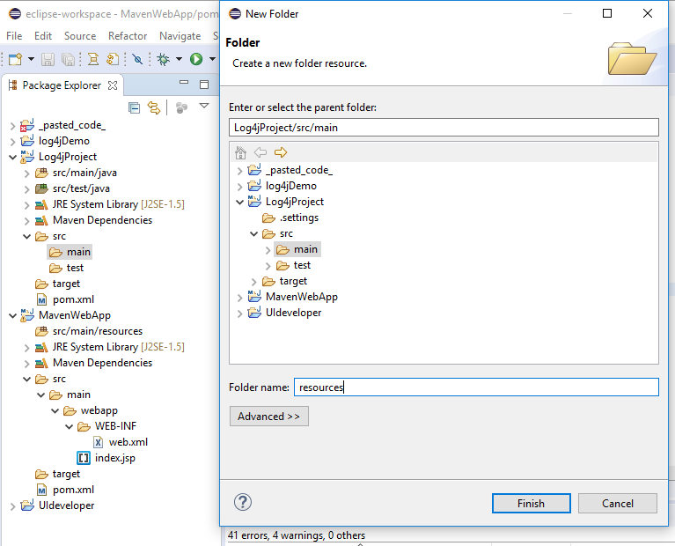

In Resources folder create a log4j2.properties file.

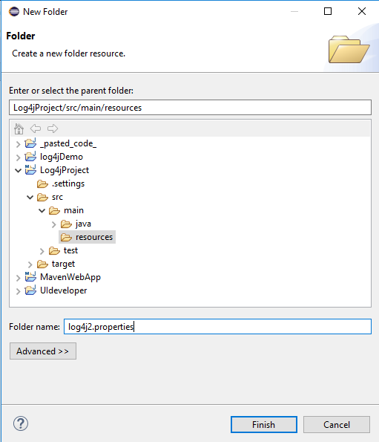

Go to log4j2.properties and give the properties,That properties are available in browser youcan google it.

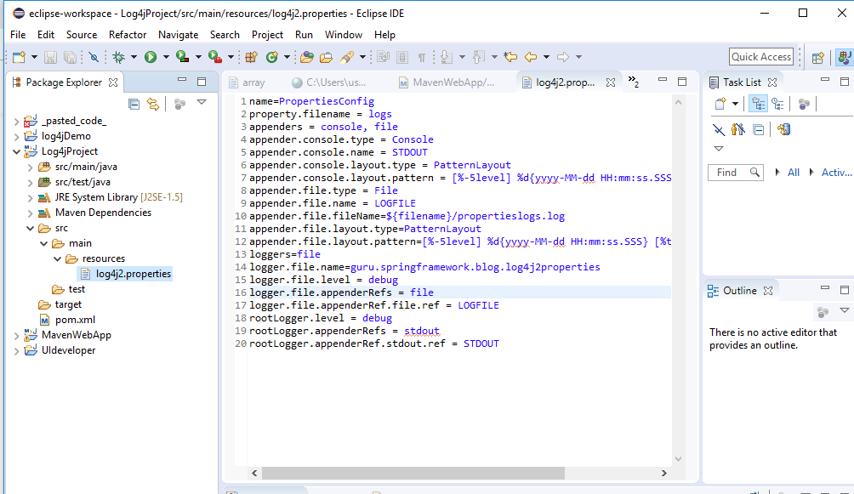

You can change the appender.file.filename=mylogger.log.

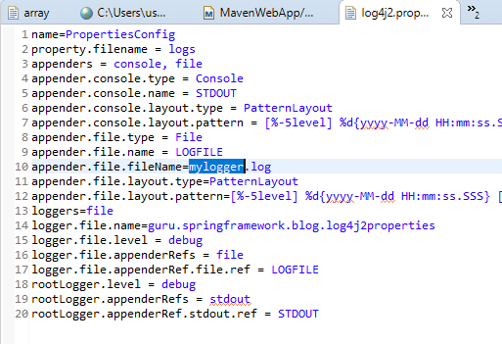

After changing name we have to give again package change,here

logger.file.name=net.javaguide.maven_web_project.Log4jProject

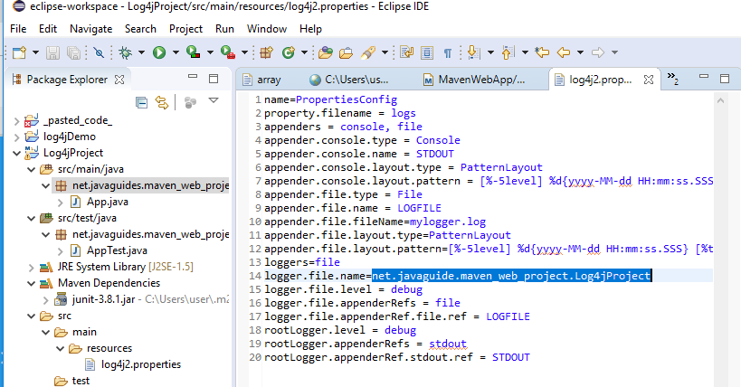

Do a small coding to test that logger is working or not?

Coming that( App.java )here we create that object of logger and write the statement

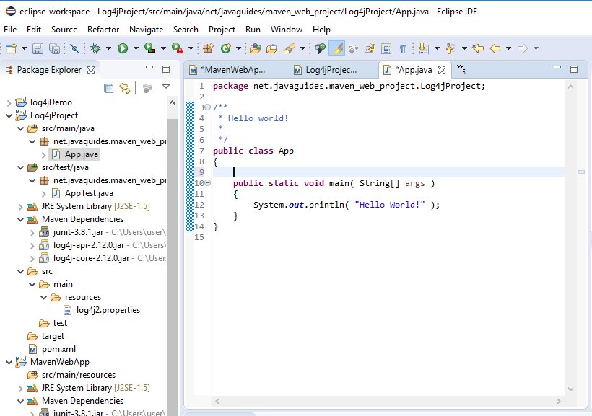

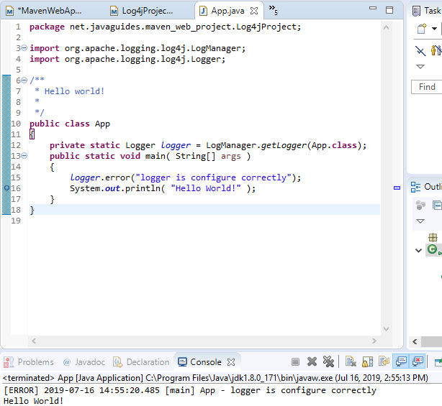

Here logger statement is printed,now we have to check logger file is generated or not.

Go to project and right click then refresh .

Here we got successfully configured.

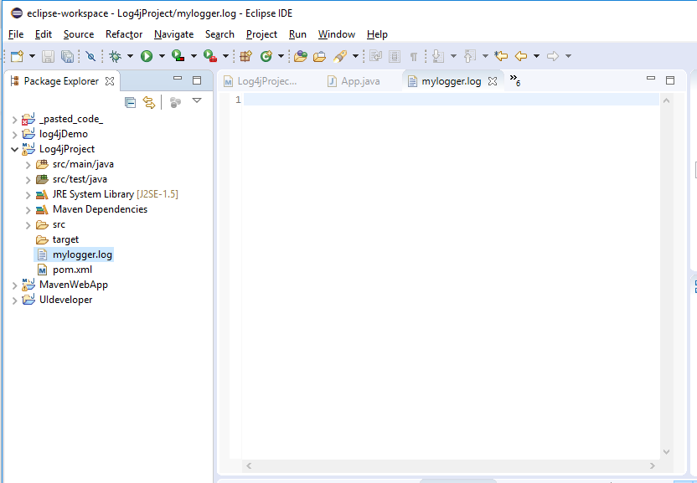

How t integrate log4j audit with maven project in eclipse